**Ideation Phase**

**Brainstorm&Idea Prioritization Template**

|  |  |
| --- | --- |
| Date | 17 november 2022 |
| Team ID | **PNT2022TMID04163** |
| Project Name | Statistical Machine Learning Approaches to Liver Disease Prediction |
| Maximum Marks | 4 Marks |

**Step-1: Team Gathering, Collaboration and Select the Problem Statement**

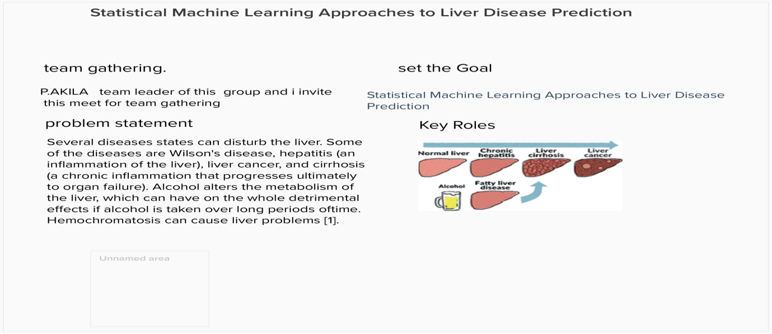

**Step-2: Brainstorm, Idea Listing and Grouping**



**Step-3: Idea Prioritization**



